Heist Dice
Project Version 2

by Norman Lee
for CSC-5
Date: 7/29/15

-Introduction-

Heist Dice is inspired from a game called Zombie Dice. You play a team of robbers who try to get as much loot as possible, while trying to avoid getting strikes on your record. Like Zombie Dice everything is determined by weighted, colored dice; the dice representing a heist you are trying to pull off. The different colors of dice indicate how difficult the job will be. Each round represents a member of your crew. Your opponent is a rival robbery gang. Compete to find out who is the best!

-Instructions-

In Heist Dice, you roll to see if you get loot, escape without harm or get caught and end up with a strike on your record. Your first action is to pick a random dice of out a bag. There are 3 different colors of dice, each weighted differently. Green dice have the highest number of sides with loot, Red dice have the highest number of strikes, and Yellow dice have even odds for all outcomes. Every round pull a dice out of a bag and roll the dice until you either get 3 strikes or choose to stop. If you get 3 strikes, your crew member faces life in prison and is forced to give up all the loot to get a plea deal. You take turns rolling with your opponent for 3 rounds and whoever has the most points at the end wins.

-Design Details-

My strategy for coding this game was to first start by programing the dice. Being as this is an original game, I could change the rules during the process, so the next step was setting up a tentative system so I could test various ways of playing the game. I originally had it so, like Zombie Dice, you chose to continue after each roll. But after testing it, the system felt too random and your choices didn't really matter. Zombie Dice has some elements to it that give it more strategy; like the fact you roll 3 dice at a time and keep dice that roll footprints. I felt that rolling 1 dice portrayed the theme of my game better as each die roll would be like a “job” the character would do. It didn't make sense to have 3 different heists run concurrently. My solution was to make the choice of rolling happen when you get a random color for your dice. The draw back in having not set rules from the start is I ended up spending a lot of time shuffling code between different functions and trying to make them work the way that made the most sense. For project 2, I mostly tried to add features that would fulfill the requirements from the check list.

-Flow Charts-

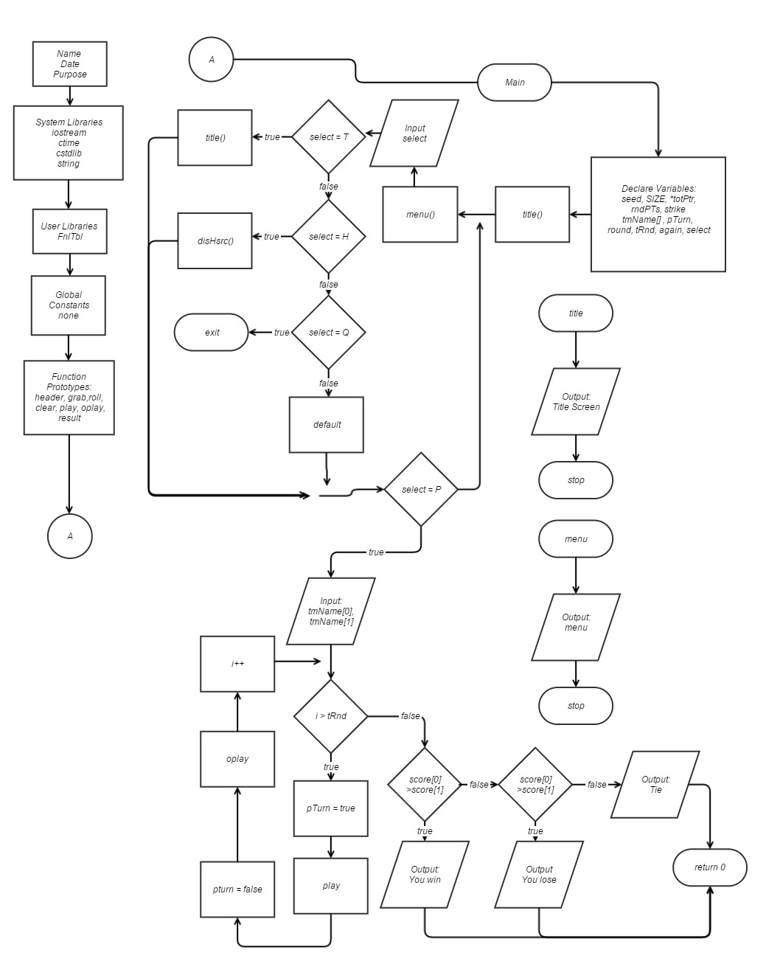
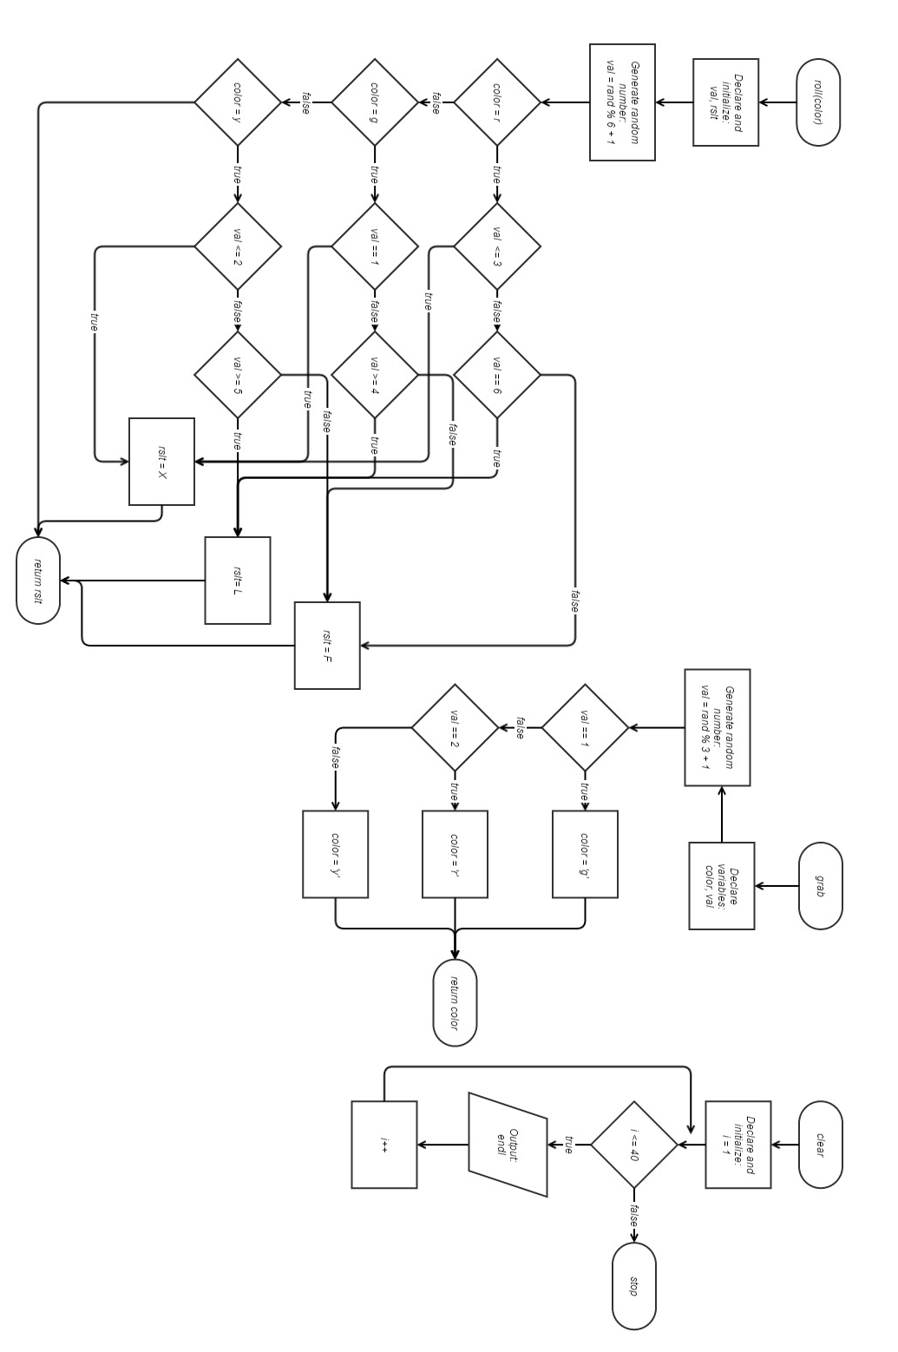
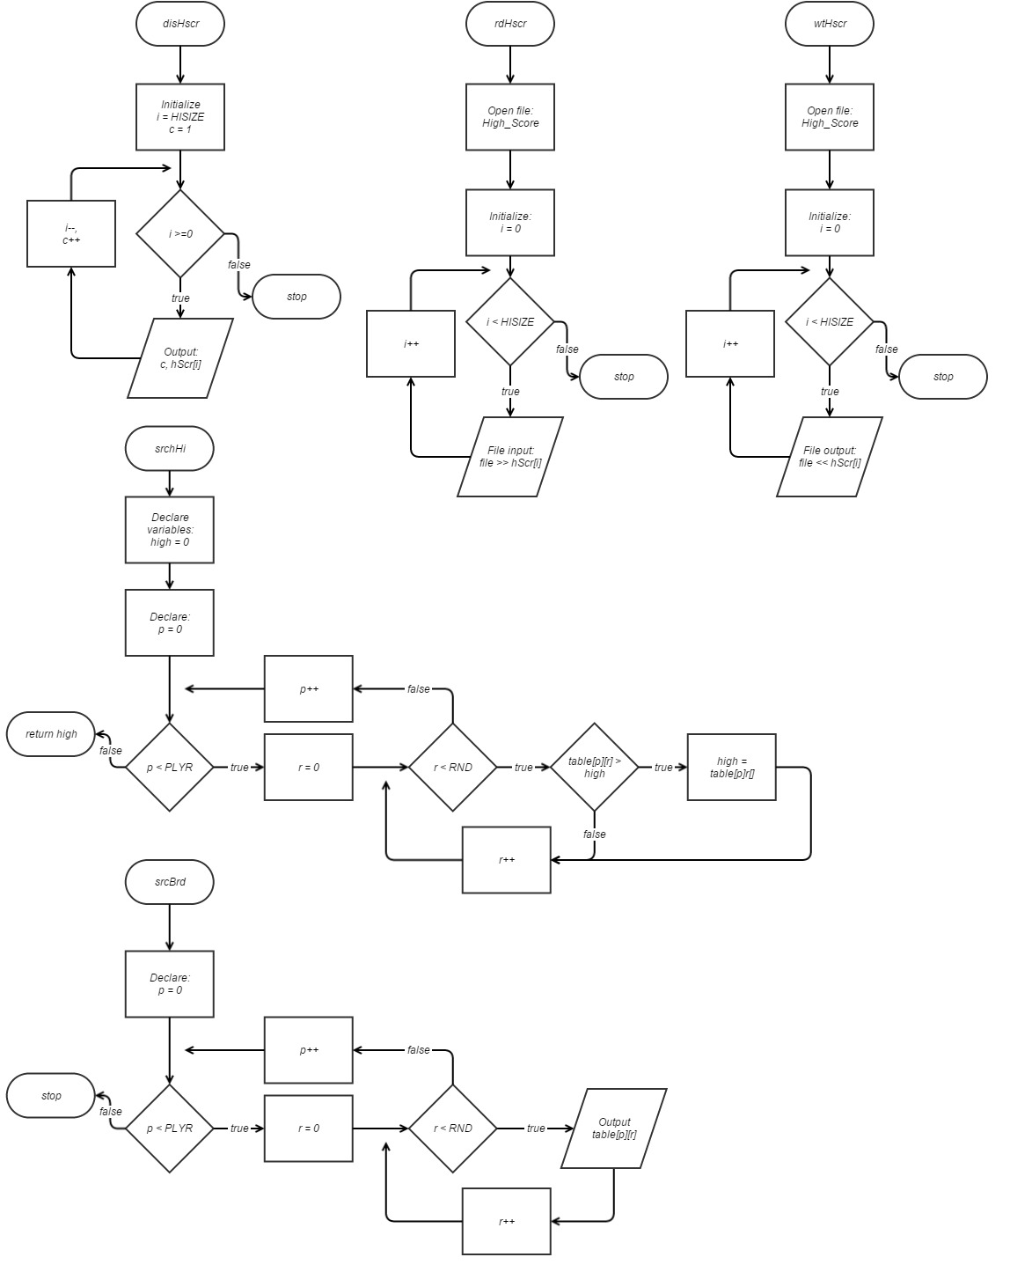

-Pseudo-code-
Start Game:
read high scores
print title
print menu
prompt for menu selection
if title
print title
if high score
print high score
if quit
exit
if play
continue
Setup Game:
get the teams names
get the amount of money to be bet
if bet > bank
exit

Play Game:
Repeat once for each round
Player has a turn
Computer has a turn
Add up score
Display points

Get dice:
random 1 – 10
if 1-5
green dice
if 9,10
red dice
if 6-8
yellow dice

Roll dice:
random 1 -6
if red
1 – 3 = strike
6 = point
4,5 = nothing
if green
1 = strike
4 – 6 = point
2,3 = nothing
if yellow
1,2 = strike
5,6 = point
3,4 = nothing

Player's turn:
Get random color dice
Prompt for roll or pass
if roll
then roll the dice
get result
if strike
add strike
if loot
add round point
if there are 3 strikes
lose all round points
end the turn
if pass
add all round points to total
end turn

Computer's turn:
Get random color dice
roll dice
if strike = 2
pass
add round points to total

End Game:
Create box score in a structure from round data, total points and team names
Display box score
if player has more points
player wins
add bet to cash
if computer has more points
computer wins
subtract bet from cash
if tie
its a draw

if players total points is higher than the lowest high score
replace the lowest score
sort the list
write the list to the high score file
display list and what place on the list the player achieved
else
subtract the lowest high score from this games total
display by how much the player missed making the top ten

-Major Variables Used-

Type | Variable | Description | Location
int | SSIZE | Size of the array for number of teams | main
int | HISIZE | Size of the array for high scores | main
int | table[][] | 2d array that hold scores of all rounds | main
int | hSrc[] | Array to hold the high scores | main
int | totPtr | Pointer “array” to hold total points | main
unsigned short | rndPts | Points earned this round | main
unsigned short | strike | Number of strikes this round | main
string | tnName | Array for team names | main
float | bet | amount the player wishes to bet
float | cash | amount of money you have | main
int | places | Counter to determine where you are on the high score list | main
char | select | Variable for the menu selection | main
bool | swap | swap for bubble sort | main
bool | pTurn | Is it the player's turn | main
short | round | The round number | main
int | tRnd | Total number of rounds in a game | main
bool | again | Does the user choose to play | main
char | color | Represents the color of the dice | grab
short | val | Random number used to determine the color of the dice | grab
char | val | Random number to determine to outcome | roll
char | rslt | Outcome determined by random number and color of the dice. | roll
char | color | Copied value from grab() | result
char | rslt | Copied value from roll | result
char | rolling | Does the player wish to roll the dice he grabbed | result
int | high | Value used in finding the highest number | srchHi

-Topics Covered-

Topic | Sub-category | Location
Basic Programs | cout, cin | cout << "You have $" << cash << ", how much do you want to bet: ";  cin >> bet;
Basic Programs | bool, char, short, int, long | short round = 0;  bool pTurn = true
Basic Programs | float | float cash = 500.00f
Basic Programs | string | string tmName[SSIZE]
Basic Programs | Comments | //Get seed off time and get "random" numbers
Expression, Libraries, Formatting | Mathematical Statements | *(totPtr + 1) += rndPts;
Expression, Libraries, Formatting | Constants | const int PLYR = 2;
Expression, Libraries, Formatting | Formatting | cout << "#" << setw(2) << c << "." << setw(15)<< hScr[i] << endl;
Expression, Libraries, Formatting | File Input/Output | ifstream infile;
Decisions | Relational Operators | totPtr[0] >= hScr[0]
Decisions | Logical Operators | }while(rolling != 'y' && rolling != 'n' );
Decisions | If | if (pTurn == true)
Decisions | If-else | else  {  disHscr(hScr, HISIZE);
Decisions | else if | else if (*(totPtr + 1) > *totPtr)
Decisions | switch | switch(select)
Loops | Increment / Decrement | i++, c--
Loops | while | while(again == true)
Loops | do while | do  {  cout << "Do you wish to roll the dice?(y/n)";  cin >> rolling;  if (isupper(rolling));  {  rolling = tolower(rolling);  }  }while(rolling != 'y' && rolling != 'n' );
Loops | for | for(int i = 0; i < SSIZE; i++)
Loops | counter | places++
Loops | nesting | for(int p = 0; p < PLYR; p++)  {  for(int r = 0; r < RND; r++)
Functions | Prototyping | void menu();
Functions | No Parameters | void title();
Functions | Multiple Parameters | void play(bool &again, bool &pTurn, unsigned short &rndPts, unsigned short &strike, int *totPtr, short &round, string tmName[], int table[][RND], int PLYR)
Functions | Pass by Reference | bool &again
Functions | Void | void title();
Functions | Return | srchHi(int table[][RND], int PLYR), return high
Arrays | 1-Dimensional | string tmName[SSIZE] = {};
Arrays | 2-Dimensional | int table[PLYR][RND] = {};
Arrays | Pass into Function | srchHi(int table[][RND], int PLYR)
Search and Sort | Search | srchHi(int table[][RND], int PLYR)
Search and Sort | Sort | //Bubble Sort
Pointers | Dynamic Arrays | int *totPtr = new int [SSIZE]();
ADT | Structures | struct FnlTbl
Files | Ascii | High_Score.txt

/*
* File: main.cpp
* Author: Norman Lee
* Created on July 17, 2015, 3:09 AM
* Purpose: Heist Dice - a game based off Zombie Dice.
*/

//System Libraries
#include <iostream>
#include <ctime>
#include <cstdlib>
#include <string>
#include <fstream>
#include <iomanip>
using namespace std;

//User Libraries
struct FnlTbl
{
string name;
int rnd1;
int rnd2;
int rnd3;
int ttl;
};

//Global Constants
const int PLYR = 2;
const int RND = 3;

//Function Prototypes
void menu();
void title();
void clr();
char grab();
char roll(char);
void result(unsigned short &, unsigned short &, bool &, bool &);
void play(bool &, bool &, unsigned short &, unsigned short &, int *, short &, string [], int[][RND], int);
void oplay(bool &, bool &, unsigned short &, unsigned short &, int *, short &, string [], int[][RND], int);
void scrBrd(const int[][RND], int);
int srchHi(int [][RND], int);
void disHscr(int [], int);
void rdHscr(int [], int);
void wtHscr(int [], int);

//Execution begins here
int main(int argc, char** argv) {

//Get seed off time and get "random" numbers
int seed = time(0);
srand(seed);

//Declare and Initialize variables
const int SSIZE = 5, HISIZE = 10; //number of total score slots, number of high scores
int *totPtr = new int [SSIZE](); //Array to keep track of both you and your opponents score
int table[PLYR][RND] = {}; //table for score in each round.
int hScr[HISIZE]; //High scores
unsigned short rndPts = 0, strike = 0; //points and strikes accrued this round
char select = 0; //selected choice for menu
int places = 0; //counter to find what place you got
string tmName[SSIZE] = {}; //array to hold team names
bool pTurn = true, again = true, swap = false; //Is it the player's turn? / do you want to play again
short round = 0; //The round number. Not the Indiana Jones character.
int tRnd = 3; // Total rounds to be played
float cash = 500.00f, bet = 0.0f; // how much cash you have and how much you choose to bet

//Open file
ifstream infile; // File that holds the amount of money you have
infile.open("bank.txt");
infile >> cash;
infile.close();
rdHscr(hScr, HISIZE); // get the high scores from the file

//Output Start Page
title();
clr();
do{
menu();
cin >> select;
if (islower(select));
{
select = toupper(select);
}
cin.ignore();
switch(select){
case 'T':
{
clr();
title();
break;
}
case 'Q':
{
exit(1);
}
case 'H':
{
clr();
disHscr(hScr, HISIZE);
break;
}
default: clr();
};
}while(select != 'P');

//Get names of the teams
cout << "Enter the name of your team:";
getline(cin, tmName[0]);
cout << "Enter the name of your opponent's team:";
getline(cin, tmName[1]);

//Prompt for a bet
cout << "You have $" << cash << ", how much do you want to bet: ";
cin >> bet;
cin.ignore();
if (bet > cash) //Please gamble responsibly
{
cout << "You shouldn't gamble more money than you have. Please get help.";
exit(1);
}

//Start the game and loop for the number of rounds
for (int i = 1; i <= tRnd; i++)
{
//Initialize/Reset conditions for the start of the round
again = true;
round++; //Add one to start the round
//Start your turn
pTurn = true;
play(again, pTurn, rndPts, strike, totPtr, round, tmName, table, PLYR);
//Start opponent's turn
pTurn = false;
oplay(again, pTurn, rndPts, strike, totPtr, round, tmName, table, PLYR);
//End of round phase
clr();
scrBrd(table, PLYR);
cout << "Round " << round << " is over. \n" << tmName[0] << " has " << *totPtr << " points.\n" << tmName[1] << " has " << *(totPtr + 1) << " points.\n";
cout << "Press enter to continue\n";
cin.ignore();
}
clr();

//Structure used to make the table for the final report
FnlTbl report[SSIZE];
for(int i = 0; i < SSIZE; i++)
{
report[i].name = tmName[i];
report[i].rnd1 = table[i][0];
report[i].rnd2 = table[i][1];
report[i].rnd3 = table[i][2];
report[i].ttl = totPtr[i];
}
cout << setw(16) << left << "Player:" << right << setw(9) << "Round 1" << setw(10) << "Round 2"
<< setw(10) << "Round 3" << setw(12) << "Total\n";
cout << "-----------------------------------------------------------" << endl;
cout << setw(15) << left << report[0].name << right << setw(10) << report[0].rnd1 << setw(10) << report[0].rnd2
<< setw(10) << report[0].rnd3 << setw(10) << report[0].ttl << endl;
cout << setw(15) << left << report[1].name << right << setw(10) << report[1].rnd1 << setw(10) << report[1].rnd2
<< setw(10) << report[1].rnd3 << setw(10) << report[1].ttl << endl;

//Get highest score
cout << "The most amount of points scored in a round was " << srchHi(table, PLYR) << ".\n";

//Determine who won
if (*totPtr > *(totPtr + 1))
{
cout << tmName[0] << " Wins! ";
cash += bet;
cout << "You now have $" << cash << ".\n";
}
else if (*(totPtr + 1) > *totPtr)
{
cout << tmName[1] << " Wins... ";
cash -= bet;
cout << "You now have $" << cash << ".\n";
}
else
{
cout << "It's a draw. ";
}

//High Score Section
cout << "Press Enter to continue: ";
cin.ignore();
if (totPtr[0] >= hScr[0]) //if your score was higher that the lowest score on the list
{
hScr[0] = totPtr[0]; //Replace the lowest score with your score
//Bubble Sort
do
{
swap = false;
for(int i = 0; i < (HISIZE -1); i++)
{
if (hScr[i] > hScr[i + 1])
{
hScr[i] = hScr[i]^hScr[i + 1];
hScr[i + 1] = hScr[i]^hScr[i + 1];
hScr[i] = hScr[i]^hScr[i + 1];
swap = true;
places++;
}
}
} while(swap);
//Output what place you got
disHscr(hScr, HISIZE);
wtHscr(hScr, HISIZE); //Write the new high score list to file
cout << "You are number " << HISIZE - places << " on the high score list.";
}
else
{
disHscr(hScr, HISIZE);
cout << "You missed making it into the top ten by " << hScr[0] - totPtr[0] << endl;
}
//Output the cash back into the file
ofstream outfile;
outfile.open("bank.txt");
outfile << fixed << setprecision(2);
outfile << cash;
outfile.close();
delete [] totPtr;
return 0;
}

//***********************************grab***************************************
// Purpose: Simulate grabbing a dice out of the bag and getting a random color
// Outputs: color -> g = green, r = red, y = yellow
//******************************************************************************
char grab()
{
char color;
short val;
val = rand()% 10 + 1;
//determine color of dice grabbed
if (val <= 5) //50% chance for green
{
color = 'g';
cout << "A Green Dice has been pulled out of the bag.\n";
}
else if (val >= 9) //20% chance for red
{
color = 'r';
cout << "A Red Dice has been pulled out of the bag.\n";
}
else
{
color = 'y'; //30% chance for yellow
cout << "A Yellow Dice has been pulled out of the bag.\n";
}

return (color);
}

//***********************************roll***************************************
//Purpose: Roll a dice and get a weighted outcome based on the color
//Input: dice -> the color of dice
//Output: rslt -> weighted results, green has the highest positive outcome,
//reds have the lowest, yellows are even
//******************************************************************************
char roll(char dice)
{
char val, rslt;
val = rand()%6 + 1;
if (dice == 'r') //Red dice, weighted with 50% chance of a strike
{
if (val <= 3) //%50 chance of a strike
{
rslt = 'X'; //you got caught/a strike
}
else if (val == 6) //1/6 chance for a point
{
rslt = 'L'; //you got loot/a point
}
else //1/3 chance to get away
{
rslt = 'F'; //you failed to get loot but got away
}
}
else if (dice == 'g') //Green dice, weighted with a 50% chance to get you Loot
{
if (val == 1) //1/6 chance of a strike
{
rslt = 'X'; //you got caught/a strike
}
else if (val >= 4) //1/2 chance of a point
{
rslt = 'L'; //you got loot/a point
}
else //1/3 chance of getting
{
rslt = 'F'; //you failed to get loot but got away
}
}
else if (dice == 'y') //Yellow dice, weighted with even odds for all outcomes
{
if (val <= 2)
{
rslt = 'X'; //you got caught/a strike
}
else if (val >= 5)
{
rslt = 'L'; //you got loot/a point
}
else
{
rslt = 'F'; //you failed to get loot but got away
}
}
return (rslt);
}

//**************************result***********************************
//Purpose: Add points or strike and output ascii picture
//Inputs:
// rndPts -> points for this round
// strike -> number of strikes
// again -> play again?
// pTurn -> is it the players turn
//Outputs:
// rndPts
// strike
//*******************************************************************
void result(unsigned short &rndPts, unsigned short &strike, bool &again, bool &pTurn)
{
char rslt = 0, color = 0, rolling = 0; // copied values for color and the value you get from rolling
color = grab(); //grab a dice from the bag and find out which color you got //Check if user wants to roll
if (pTurn == true)
{
do
{
cout << "Do you wish to roll the dice?(y/n)";
cin >> rolling;
if (isupper(rolling));
{
rolling = tolower(rolling);
}
}while(rolling != 'y' && rolling != 'n' );

if (rolling == 'n')
{
again = false;
}
cin.ignore();
}
if (pTurn == false || rolling == 'y')
{
rslt = roll(color); //roll the dice and get the value
clr();
//Output representation of the dice and increment strikes or points based on roll result
if (rslt == 'L')
{
cout << ".-----------.\n"
<< "| $$$$$ |\n"
<< "| $ $ |\n"
<< "| $ $ |\n"
<< "| $ $ |\n"
<< "| $$$$$$$ |\n"
<< "'-----------'\n";
cout << "Successfully stole some loot!\n";
rndPts++;
}
else if (rslt == 'X')
{
cout << ".-----------.\n"
<< "| x x |\n"
<< "| x x |\n"
<< "| x |\n"
<< "| x x |\n"
<< "| x x |\n"
<< "'-----------'\n";
cout << "Got caught and a strike was placed on your record.\n";
strike++;
}
else
{
cout << ".-----------.\n"
<< "| RRRRR |\n"
<< "| R R |\n"
<< "| R RRRR |\n"
<< "| R R |\n"
<< "| RRRRRRRRR |\n"
<< "'-----------'\n";
cout << "Failed at the attempt but got away.\n";
}
}
}
//Purpose: Generate a title with information
void title()
{
cout << " . . . . . . . . . . . . . . . . . . . . . . . . . . . . . . . . . . . . ..-----------. . . . . .\n"
<< ". . . . . $ . .$. .$$$$ . $ .$$$$$$ $$$$$$. . . 8888. 8 .888. .8888 . . . | $$$$$ |. . . . . \n"
<< " . . . . .$. . $ . $ . . .$.$$ . . . .$. . . . .8. .8.8.8. .8. 8 . . . . .| $ $ | . . . . .\n"
<< ". . . . . $$$$$$. .$$$. . $ .$$$$$. . $ . . . . 8 . 8 8 8 . . .888. . . . | $ $ |. . . . . \n"
<< " . . . . .$. . $ . $ . . .$. . . $$. .$. . . . .8. .8.8.8. .8. 8 . . . . .| $ $ | . . . . .\n"
<< ". . . . . $ . .$. .$$$$ . $ $$$$$$. . $ . . . . 8888. 8 .888. .8888 . . . | $$$$$$$ |. . . . . \n"
<< " . . . . . . . . . . . . . . . . . . . . . . . . . . . . . . . . . . . . .'-----------' . . . . .\n"
<< "How to play Heist Dice: Every round you get to roll the dice.\n\n"
<< "There are 3 different outcomes you get from rolling: A loot bag, shoes, and a strike.\n"
<< "--------------------------------------------------------------------------------------------------\n"
<< "Loot bags: you score a point for the round.\n"
<< "Shoes: nothing good or bad happens.\n"
<< "Strikes: If you get 3 strikes, the round ends and you lose any points you made for that round.\n"
<< ".-----------. .-----------. .-----------.\n"
<< "| $$$$$ | | RRRRR | | x x |\n"
<< "| $ $ | | R R | | x x |\n"
<< "| $ $ | | R RRRR | | x |\n"
<< "| $ $ | | R R | | x x |\n"
<< "| $$$$$$$ | | RRRRRRRRR | | x x |\n"
<< "'-----------' '-----------' '-----------'\n\n"
<< "There are 3 types of die: Green, Red and Yellow.\n"
<< "--------------------------------------------------------------------------------------------------\n"
<< "Green: Has the highest amount of loot bags and only 1 strike.\n"
<< "Red: Has the highest amount of strikes and only 1 loot bag.\n"
<< "Yellow: All outcomes have an equal chance.\n"
<< "--------------------------------------------------------------------------------------------------\n"
<< "After you grab a dice from the bag you can choose to stop and keep the points you have accrued.\n"
<< "There are 3 rounds, you and your opponent take turns rolling for each round.\n";
cout << "<Press Enter to continue>\n";
cin.ignore();
}

//Purpose: Displays a menu
void menu()
{
cout<<"------------Menu-------------"<<endl;
cout<<"| Press: |"<<endl;
cout<<"| |"<<endl;
cout<<"| (P)lay the game |"<<endl;
cout<<"| (T)itle Screen |"<<endl;
cout<<"| (H)igh Scores |"<<endl;
cout<<"| (Q)uit |"<<endl;
cout<<"----------------------------|"<<endl;
}

//Purpose: uses 40 new lines to clear the screen
void clr()
{
for(int i = 1; i <=40; i++)
{
cout << endl;
}
}
//*******************************play*******************************************
//Purpose: Player's turn to play the game
//Inputs:
// again -> play again, true or false
// rndPts -> points this round
// strike -> strikes this round
// totPtr[] -> total scored points
// round -> the round number
// tmName -> the your team name
//Outputs:
// again -> play again?
// rndPts -> points this round
// strike -> strikes this round
// totPtr[] -> total scored points
// tmName -> the your team name
//******************************************************************************
void play(bool &again, bool &pTurn, unsigned short &rndPts, unsigned short &strike, int *totPtr, short &round, string tmName[], int table[][RND], int PLYR)
{
while(again == true)
{
cout << "Round " << round << "<Your turn>" << endl;
result(rndPts, strike, again, pTurn);
if (again == false) //When you stop rolling your points get added to your total
{
*totPtr += rndPts;
table[0][(round-1)] += rndPts;
rndPts = 0;
strike = 0;
cout << "Added point(s) to total. " << tmName[0] << " has " << *totPtr << " total points.\n\n";
}
if (strike >= 3) //If you get 3 strike lose all points
{
cout << tmName[0] << " member <" << round <<"> has 3 strikes. Facing life in prison, you give up all your loot for a plea deal.\n\n";
rndPts = 0;
again = false;
strike = 0;
}
else
{
if (again == true)
{
cout << tmName[0] << " member <" << round << "> has " << rndPts << " points this round and " << strike << " strikes. " << tmName[0] << " has " << *totPtr << " total points.\n\n";
}
}
cout << "<Press Enter to continue>\n";
cin.ignore();
}
}
//***********************************oplay**************************************
//Purpose: Have the computer opponent play
//Inputs:
// again -> play again, true or false
// rndPts -> points this round
// strike -> strikes this round
// totPtr[] -> total scored points
// round -> the round number
// tmName[] -> the computer's team name
//Outputs:
// again -> play again?
// rndPts -> points this round
// strike -> strikes this round
// totPtr[] -> total scored points
// oTeam -> the computer's team name
//******************************************************************************
void oplay(bool &again, bool &pTurn, unsigned short &rndPts, unsigned short &strike, int *totPtr, short &round, string tmName[], int table[][RND], int PLYR)
{
again = true;
while (again == true)
{
result(rndPts, strike, again, pTurn);
cout << tmName[1] << " member " << round <<" has "<< rndPts << " points and " << strike << " strikes.\n" << endl;
cout << "Round " << round << " <Opponent's turn>" << endl;
cout << "<Press enter to continue>\n";
cin.ignore();
if (strike >= 2)
{
//Add round points to total score and reinitialize
*(totPtr + 1) += rndPts;
table[1][(round-1)] += rndPts;
rndPts = 0;
strike = 0;
cout << tmName[1] << " chooses to stop. \n" << "Adding point(s) to total. " << *(totPtr + 1) << " total points for "<< tmName[1] <<".\n";
again = false;
cout << "<Press enter to continue>\n";
cin.ignore();
}
}
}
//*********************************scrBrd***************************************
//Purpose: Keep tally for each of the rounds
//Inputs:
// table[][RND] -> the table to output
// PLYR -> the player row
//Outputs:
// table[PLYR][RND] -> a table with the score for each round so far
//******************************************************************************
void scrBrd (const int table[][RND], int PLYR)
{
cout << "Scoreboard:\n";
for(int p = 0; p < PLYR; p++)
{
for(int r = 0; r < RND; r++)
{
cout << table[p][r] << " ";
}
cout << endl;
}
}

//Purpose: Search for the highest round score
int srchHi(int table[][RND], int PLYR)
{
int high = 0; // highest
for(int p = 0; p < PLYR; p++)
{
for(int r = 0; r < RND; r++)
{
if (table[p][r] > high)
{
high = table[p][r];
}
}
}
return high;
}

//Purpose: Displays High Score counting down
void disHscr(int hScr[], int HISIZE)
{
cout << "----High Scores----\n";
for(int i = HISIZE -1, c = 1; i >= 0; i--, c++)
{
cout << "#" << setw(2) << c << "." << setw(15)<< hScr[i] << endl;
}
cout << "-------------------\n";
}

//Purpose: Reads file to get high scores
void rdHscr(int hScr[], int HISIZE)
{
ifstream file;
file.open("High_Scores.txt");
file.clear();
//Loop add the data from the file to the array
for(int i = 0; i < HISIZE; i++)
{
file >> hScr[i];
}
file.close();
}

//Purpose: Writes high scores back into the file
void wtHscr(int hScr[], int HISIZE)
{
ofstream file;
file.open("High_Scores.txt");
//Loop output the array to the file
for(int i = 0; i < HISIZE; i++)
{
file << hScr[i] << " ";
}
file.close();
}

